Digital mocking pattern using virtual reality for development of human-centric assembly systems

Abstract
The advent of Industry 5.0 marks a pivotal shift from a techno-centric to a human-centric focus. In navigating this transition, design patterns emerge as invaluable tools, empowering developers to adeptly address common challenges by imparting structure to solutions, modularly separating components for reuse, and fostering a shared vocabulary that enhances communication.
This research advocates for the integration of a digital mock pattern into the development of human-centric systems. In this approach, a virtual workstation (digital twin) replaces the physical counterpart during development and testing. This substitution allows for the validation of assumptions and fine-tuning of a human performance model without changes in hardware.
The versatility of this pattern is demonstrated through its retro-reflection in three previously published articles, showcasing its adaptability to various tasks. These tasks encompass validating established models within specific domains, exploring novel models, creating sample-efficient dynamic scheduling systems, and devising decision frameworks that leverage human performance data.
Our findings underscore the applicability of this pattern to diverse case studies, emphasizing its flexibility. Additionally, we propose that its utilization fosters novel applications by enabling the combination of components in a virtual prototyping environment that facilitates rapid iteration.
This methodology is relevant to domains where human-error risk is elevated, such as medical surgery, military applications, long-distance driving, and mining. The costs of developing a virtual workstation can be significant, highlighting the importance of conducting a case-by-case feasibility check to assess viability.
In essence, the digital mock pattern emerges as a potent ally in the pursuit of human-centric development, offering not only adaptability to varied scenarios but also the potential to enhance creativity and innovation in the design process.

Introduction

Man-machine system design
The design of man-machine systems is well known for its challenges. It is often described as a wicked set of problems [] due to (1) inherent complexity of predicting human behaviour resulting in small changes leading to unexpected outcomes, (2) resistance to resolution in terms of interaction between multiple components and stakeholders views offering multiple local optima with little common language, and (3) an iterative approach due to difficulty of simulation resulting in an emphasis on real world validation data.
Design methodologies address the issues of designing artefacts in situations were the objective and outcomes are not clear.
The design of these systems have received a sustained amount of attention. For example:
- [1] Describes the limitations of top-down approaches to as “integrating of complex systems”, finding suboptimal solutions due to the inherrent complexity of the system.
  - Bottom-up approaches are techno-centric and “not sufficient for resolving the many types of problem”, using the example of human-factors engineers insuring sufficient placement of displays, inputs, and physical environments.
  - He offers an advancement in terms of “supporting reality” through
    - easy-access to information that is “good-enough”
    - Rapid prototyping
    - Communication with other designers including incumbent users (operators, maintainers, etc.)
    - feedback.
- Design Science Research [2] is an iterative approach popularized in information systems that address these issues. Most notably this perspective explores science through the creation of an artifact, resulting in a tight build-evaluate loop that lends itself well to man-machine interaction. This build and evaluate becomes a critical idea in dealing with the man-machine systems.

Man-machine system design as wicked problems
Let’s take the time to formalize what characteristics of wicked problems we specifically concerned with regarding Human performance models. As an example we will introduce two well-established simple laws of human performance. First the learning curve or Wright law [Wright] follows a decaying power law that predicts “the time a task takes decreases with the number of repetitions”. The second is the Time-on-task effect [Nebel] which predicts increased error rate with prolonged task durations. Similarly, the Risk Index [Folkard] demonstrated that injuries are more likely to occur later in the day.
The first property of designing HMI systems with HPM as measure is incomplete information as free parameter tuning. These laws describe human behaviour as curves, but the parameters characterizing these curves cannot be known ahead of time. Instead they are determined from experimental data. For example, the exponential and scaling components of the power law are determined from experiment as they are unique to each task/set-of-tasks. Therefore one objective is to facilitate simplified data collection. This refers to both the effort of experiments and scale of data collected. We suggest VR automates configuring the experiment environment and captures high fidelity data.
The second property of wicked system is the interconnectedness of law’s leading to uncertain outcomes and iterative approaches. Since several law’s interact and there parameters are not known ahead of time, predicting the operators performance is not feasible without experiemental data. Furthermore, an appropriate model must be determined and validated for the current task. For example, the learning curve may be sufficient for a duration of a specific task. When increasing the duration of the task, fatigue may reduce the performance, requiring a different model. This illustrates how small changes in design can have unpredictable outcomes and the common approach to solve this problem is iterative design with regular validation. We set the objective of easing validation of behaviour curves using the intelligence (DoE/statistics).

Human performance with complex interaction
This section proposes human performance modelling as complex interaction between well established “laws” of human performance, represented as curves. A simplified example allows us to reason about the interaction between the laws, and insight into why experimental data is required and how this data requirement scales with the interaction between laws.
Wright learning is arguably the best known law. Wrights Learning Curve (WLC) describes the increase in performance due to repeated tasks using the power curve. After having its roots in predicting the duration of manufacturing assembly tasks in aircraft assembly [3], it was then further expanded to other situation, most notably for our discussion learning and fatigue [4], [5].
A more elusive law is the effect of fatigue, which is the degradation in performance due to prolonged exposure/work. While the evidence of fatigue’s effect is undeniable, attempts to model it through reductionism have been largely unsuccessful. Common reasons for its behaviour is that different kinds of fatigue exists, for example physical, mental/cognitive [] or short-term, long-term []. In physical processes for example, maximum endurance time is typically used to describe initial performance of a muscular task, such as holding a weight for a fixed amount of time. Here fatigue described the degradation toward a minimum endurance time. These models vary between two limits, surprisingly resembling the vigilance decrement law [].
On the other hand, the cognitive consensus seems to align with an exponential degradation in performance. For example, injury related accidents are more likely to occur later in the day [Risk index]. An interesting finding was that medical interns were 4 times more likely to make misdiagnosis error on a 24 hour shift, compared to a 16 hour shift, hinting at an exponential decay in performance.
An interesting finding consistent across learning and fatigue models is a U-shaped response [4], [5], [6]. This is likely due to the interaction between these two curves.

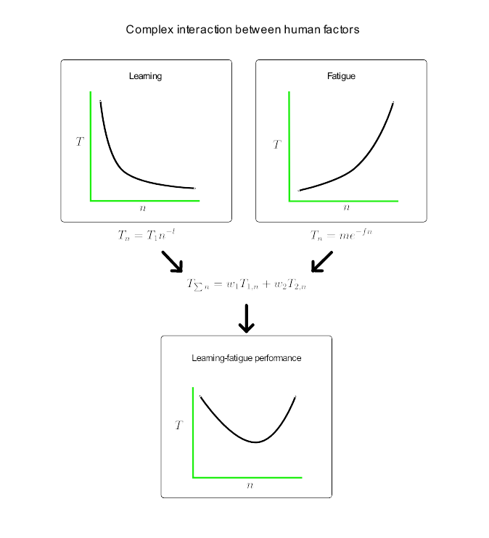
Using the above figure as an example, we demonstrate the data requirements for human-performance modelling. On the top-left, WLC (T_n=T_1 n^{-l}) and a simplified fatigue law (T_n=m e^{-fn}), these models have “free tuning parameters” ({T_1, l,m,f}) which cannot be known ahead of time and are calibrated from experimental data. The measured performance is the interaction between these two “law’s”. Here again, the weights {w_1,w_2} need to be tuned from experimental data. This significantly, increases the amount of experimental data required. Moreover, in a non-deterministic model the uncertainty further increases data required. Finally, the interactions are not always so simple. For example, [Asa] presented a fatigue dependant learning curve, which suggests that fatigue may both influence performance indirectly by influencing the learning rate (T_n=T_1 n^{-(l+f-e^{f,n}}) and influence performance directly. Note how this complex law interaction model allows for this, but will also require additional additional data.
The exercise of simplification through reductionism demonstrates why significantly less data is required. Consider a case study where the amount of fatigue has nominal effect on the process. The measurable performance is curve is dominated by WLC, translating to w_2=0. The effect on the data requirement is that fewer variables need to be tuned ({T_1,l}, assuming {w_1=1}), resulting in a significantly lower data requirements.

Software Engineering for innovative systems
This section posits software engineering as "systems engineering specialized for change," asserting that re-purposing established software engineering techniques for flexible and digital manufacturing systems yields both theoretical and practical insights. Unlike the conventional notion of development merely creating an artifact, this perspective delves into the deeper understanding of a system that is in constant construction and evolution. While software engineering is commonly associated with computer code, it fundamentally represents a form of systems engineering, where code is an outcome of the implementation process.

Software flexibility
Renowned author Robert Martin describes software as "soft systems" that are inherently easy to change, distinguishing them from hardware systems, known for their resistance to change [7]. Martin draws an analogy between performance and ease of change, highlighting the impracticality of a high-performance machine that lacks adaptability. This analogy underscores the importance of constructing modular, reusable, and generalizable "soft machines" on top of hard machines to facilitate change. This contrasts with application-specific machines, emphasizing the flexibility of software in contrast to traditional manufacturing tools. Having a software layer applies to computing, robotic, and manual assembly processes, as shown in the figure below [A].
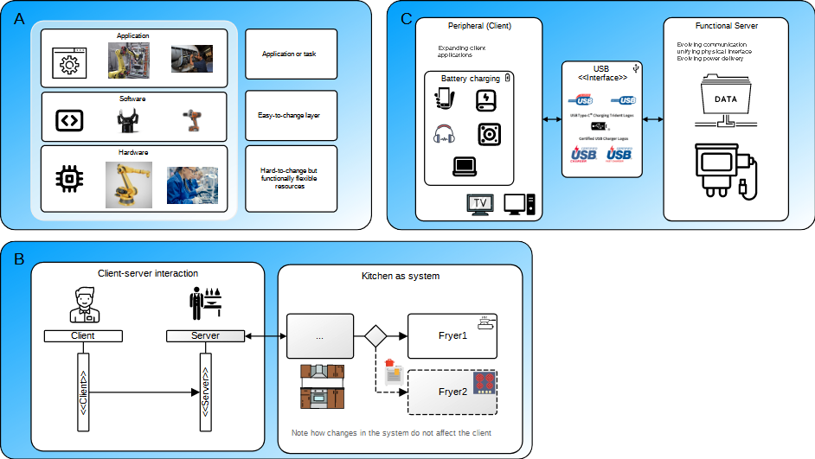
Figure 1: Applying software to non-computer systems.

Applying Software Engineering to Non-Computer Problems
The application of established software design patterns, such as the client-server design pattern, extends beyond traditional computing to non-computer problems, serving as versatile system design patterns. The take-out restaurant shown in the figure [B], illustrates design patterns do not necessarily apply to code. In this example, the pattern not only provides a structure for problem-solving but also isolate changes, minimizing the impact of modifications. For example, changes in the kitechen do not affect the client. This adherence to design patterns aligns with SOLID principles [8], fostering positive effects on system design and development.

Implications on Long-Term Applications
The ease of changing a system, as exemplified by software, holds profound implications for long-term applications. The USB standard, shown in the figure above [C], serves as a prime example, unifying various functionalities such as battery charging, data communication, and backward compatibility. This approach reduces waste by promoting modular, reusable products, provides flexibility for system adaptation to new features, and enables the maintenance of legacy products.

Revisiting the Relationship Between Manufacturing and Software
While the relationship between manufacturing and software is not a novel concept [9], this work advocates revisiting it in the context of increased flexibility and digitization. Examples demonstrate how manufacturing systems can benefit from applying software engineering methodologies, emphasizing the utility of design patterns in offering reusable solutions and best practices while simplifying complex problem-solving.

Objectives
This work specializes an existing software design pattern to address the challenges posed by human operators.

Background

Challenges in measuring human operators
Measuring humans poses greater challenges compared to machines. One difference is the extended operational hours of machines. Machine operators can work for 20 hours or more in a single shift, a practice deemed unethical for humans. The prolonged operational periods of machines allow us to collect more data over extended time frames.
The second challenge is the effect of measuring. While retrofitting a machine with additional sensors presents minor challenges, the same cannot be said for humans. Measuring operator's state, performance, and activities are invasive. While this may seem like a small issue that can be overcome with time, measuring is associated with higher levels of stress, a greater risk of injury, and lower performance levels [10]. This poses the direct problem that measuring adversely affects the performance of operators, not revealing their true performance. In the case of wearable gloves and sensor-based instrumentation and tools, the cause is not psychological but physical. These gloves, tools, etc., directly interfere with the operator's agency, comfort, task familiarity, and ability to perform the given task. In the end, the act of measuring human operators can inhibit their performance, leading to biased data.
The third issue of ethical use of data is of growing concern. In general, there have been numerous scandals involving mega-corporations like Google, Facebook, and Amazon regarding the abuse of general users' data [11]. While Europe has regulated the storage location and uses of citizen data [12], they have also begun looking at the ethical use of data in the workforce [13], quoting the right to privacy [14]. Regulations inhibit the sharing of data between business entities and limit the application of data for hiring based on performance.

Challenges in modelling
Human behaviour modelling is a wicked problem from the point that “a change to resolve one aspect of the problem may create another problem”. The complexity of human models is caused by a few characteristics best juxtaposed with their machine counterparts.
Firstly, humans exhibit dynamic behaviour that can change rapidly over time due to states like learning and fatigue. Machine models, on the other hand, tend to operate under predefined rules and exhibit steady-state behaviour. This becomes obvious when we compare a 12-hour shift of industrial robot assembly with that of manual assembly. Human operators' performance is likely to suffer from reduced throughput and increased errors, while machine performance remains unchanged. Modelling the dynamic behaviour of humans is challenging and often requires real-time data.
Revealing the second issue, that human internal states like learning and fatigue are not directly measurable. This leads to estimation and observation of ill-defined quantities that can only be relatively defined. There is no absolute measure (ground truth) for internal states like fatigue and learning, making models relevant only within a small domain (limited transference). Mathematically this show’s up as an ill-conditioned problem, having several solutions. In the real-world, it shows up as different effects of the same states. For example, PERCLOSE (percentage eye-close) and instrumentation (steering wheel and chairs) are good estimator of vehicle driver fatigue [15], [16]. Yet, it was observed that seasoned long distance drivers experiencing micro-sleeps stabilized steering wheels with their legs [17]. The fatigued well experienced driver exhibts the same behaviour as the well-rested inexperienced driver. Observing the internal state will increase the model transference and is essential for suggesting actions.
Repeatability of measurements are also an issue influenced by long-term learning, interindividual variability, and biological factors. These issues are suggestive of a probablistic model instead of a deterministic one, again make modelling challenging and may require additional data.

The approach recommended here
Small changes to a workstation can result in vastly different behaviour. For this reason, regular validation is required. For example, [18] found a throughput rate valid for a range of complex tasks, while the quality risk model was valid for a subset of tasks. Let us distinguish validation from tuning, where a valid model describes the operator behaviour for a task or domain, and tuning parameters increase the accuracy of the model for the specific task. Hence, the human performance model (HPM) will need to be validated and tuned often enough that it should be included as a core component.
In order to address the challenges presented by measuring the operator, we suggest using the human performance model to observe the internal state. This is an open research question [19].

Digital mocking design pattern

Mocking design pattern
Mocking is well established design pattern that involves using a mock-model to test or develop a system component under specific considerations (state). Typically a mock component is substituted for a production component through a standardized interface. This has the effect of testing the system response under a specific state.
An interface hides the substitution making the mock indistinguishable from the production component. This has several positive effects. (1) It enables prototyping, parallel development, and deferring implementation through modular component separation. For example, a single file database could be used during development, while a large online SQL database is being developed. Similarly, different DB vendors could be investigated for feasibility. (2) It enables testing the system under artificially constructed states. The systems behaviour can be tested when the DB is empty or full. This allows testing and development of an empty, full, or locked DB without disrupting production.

Components
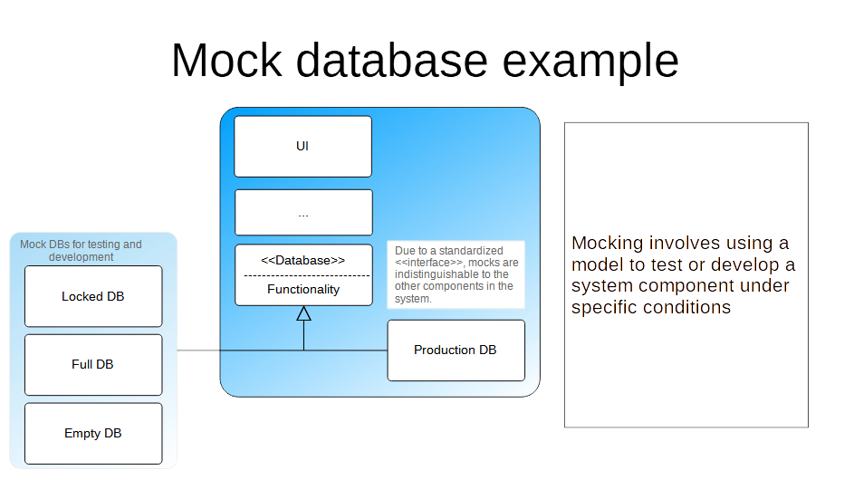Figure 2: The database (DB) example illustrates how different DB states are tested
The pattern needs to be adapted for human-centric systems, hence crucial modifications are made. Firstly, the virtual mock is introduced as a more concrete version specialized for human systems. In the case studies, we build a virtual reality version of the physical workstation with the intention of a substitutable mock. Humans interact with the virtual workstation instead of the physical one. This facilitates the rapid prototyping of new systems, reconfiguration, and development while deferring the implementation of hardware systems. This virtual substitution is similar to the digital twin but requires virtual reality as an immersive digital substitution for the physical system. This substitution is later validated in a case study.
Secondly, we introduce the human performance model. The human performance model predicts the operator outputs within a small domain. [20] suggests the digital twin as a high-fidelity model reflecting causality, and the digital shadow as a model reflecting statistics. This adequately describes the roles of the virtual workstation models and HPM respectively. Additionally, the HPM model is “cheap to compute” and serves as an abstract model that can be used elsewhere, in contrast to the “high cost” HITL simulation.
Thirdly, a scheduler takes action based on the previous output from the workstation. This could be to rest, change tasks, etc. This is not apparent from a machine point of view, but human performance is dynamic. Additionally, we make the argument that dynamic human schedulers are control systems and a means of ensuring ethical work conditions through empathetic objective functions. These modifications allow the system enough flexibility to be adapted.
The figure that follows, illustrates the pattern and case studies. The core idea, [A] is a design pattern that substitutes the virtual workstation for the physical station. The system does not know whether a virtual or physical workstation is being used. A human performance model is typically validated and fine tuned to each application.
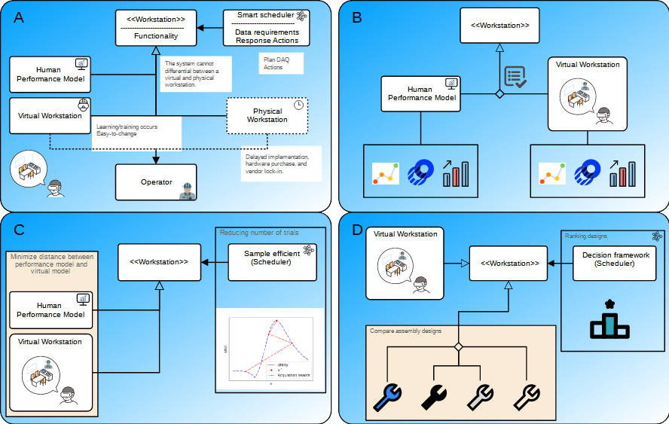Figure 3: The investigation overview showing the digital mocking design pattern [A], the virutal workstation validation [B], the sample efficient model tuning [C], and the design for assembly of additive manufacturing decision framework [D].

Case studies
By examining the previous studies through the lens of this pattern, we can present a more accessible summary of our investigation. This analysis demonstrates the innovative application of the pattern, showcasing the construction of intelligent Human-in-the-Loop (HITL) virtual assembly workstations, incorporating features such as experimental design and decision frameworks.

Virtual validation
In the initial investigation, the suitability of the virtual workstation as a substitute for the physical one was tested by examining established and novel models. A series of tasks, simulating varying degrees of complexity in common assembly tasks, including random or repeatable tasks and sequentially dependent or independent tasks, were conducted. The assessment, depicted in the figure above [B] and detailed in [14], aimed to determine if the virtual workstation could effectively replace the physical workstation. To this end, the virtual workstation performance was compared with established models.
- The Wright learning model for task duration was valid for all tasks, but the model should be fit to each task.
- The quality risk (index) of defective assembly was only valid for sequentially independent tasks. This illustrates why a validation step is required to establish whether the model holds in the applicable domain.
- The dimensional assembly error was validated. This served as an illustration to quantify a measure that is not practically measurable in the physical world. Here the digital workstation is able to quantify a measure that is not practical in the physical world. Future works may explore this, acquiring information that is impractical from physical sensors.
- The dynamic-gamma Wright learning model was proposed by enriching the previous model. This is an example of novel insights can be explored. The scale and fidelity of the data used to enrich this model was made practical by the ease of measuring in the virtual workstation.
These findings not only confirmed the virtual workstation's ability to simulate existing models but also highlighted its capacity to uncover novel insights.

Sample efficient human in the loop simulation
The subsequent investigation highlighted the significance of an intelligent scheduler. The Wright learning model, validated in the prior study, necessitated further tuning for specific tasks. This adjustment typically involves utilizing real-world data, supplied in this case by the virtual HITL workstation. Tuning the model parameters to the experiment proves costly due to the human labor associated with HITL simulation. Therefore, minimizing HITL labor would enhance the feasibility of this approach.
To address this, an online sample-efficient scheduler was developed to reduce the number of trials, functioning as a Design of Experiments (DoE) module. The reduction in experimental trials translated to decreased HITL labor for model tuning, exemplifying an empathetic objective function. In contrast, a function aiming to extract maximum data from operators would likely overburden them.
While this example is straightforward, it underscores the power and responsibility of the scheduler and its designer. Preserving operators' autonomy is crucial by allowing them to override schedulers. Additionally, human-centric schedulers should consider operators' internal emotional states, such as fatigue and learning, to ensure empathy. Caution is necessary to avoid dark patterns that may make free decisions possible but impractical, often through challenging paperwork or UI.
This development addresses a limitation in previous works, significantly increasing the scale of acquired experimental data. By combining the proposed adaptive online DoE with recent technological advances like on-device inference [21], low-cost VR, and previous findings such as remote databases and parallel DoE [22], [23], this data acquisition scale may facilitate further data-intensive applications and multi-location collaborations.
- Reducing the number of human trials used to tune a model given a valid HPM.
- Illustrating a feasible and empathetic objective function.
- Employing the scheduler creatively.
- Enabling a significant increase in experiment scalability.
This feature enhances the feasibility of HITL model tuning, significantly scaling up data collection. It is envisioned that this will encourage continuous improvement of workstations through digital prototyping.

Assembly design decision support framework
The concluding investigation demonstrates the practical application of a system constructed using the specified pattern to address contemporary challenges. This approach streamlines the selection of assembly designs by considering both printing costs and manual assembly expenses. Significantly, it enables a comparative analysis of artifacts within the system, such as different product assemblies, against external system elements like the costs associated with 3D printing. This aids in decision-making, with the HPM, scheduler, and Axiomatic design seamlessly integrated into the decision framework.
The virtual workstation assesses human performance for each assembly, while the quality of the assembly is gauged using an HPM to measure assembly dimension errors and assembly durations. These measurements are subject to testing to confirm their adherence to specific distributions. The verification of the independence between assembly duration and assembly error is conducted through data obtained from the HITL simulation. However, it remains unclear whether this relationship holds universally and necessitates confirmation on a case-by-case basis.
In summary:
- The HPM is quantified for each assembly.
- Assumptions regarding the correlation between assembly time and assembly error are validated but need confirmation on a case-by-case basis.
- Modeling assembly time and assembly error as gamma and log-normal distributions is validated.
- The decision framework combines internal and external data sources, including tuned HPM, validation of assumptions, external data, and numerous designs.
Despite the various advantages of additive manufacturing, its manufacturing flexibility presents challenges in terms of design decisions. Integrating HITL simulation with decision support facilitates navigating these opportunities. It underscores the importance of a human-centric workstation capable of validating assumptions, tuning models, incorporating external information, and simulating changes to the workstation and work piece.

Research contributions
Utilizing the digital mocking design pattern, we distilled insights from the case studies. This section delves into the contributions and implications for a human-centric manufacturing system.
The wicked nature of modelling human behaviour has caused some of the manufacturing industry to pursue a black box approach. This has several non-obvious implications. Firstly, the opacity of black box models, does not offer suggestions on process improvement where a white box model reveals factors hindering performance. Secondly, big-datasets require constantly measuring operators, typically using wearable, yet the discomfort caused by these and the performance loss is not considered. Thirdly, big-data models have lots of system inertia and are not conducive to iterative design environments. This work, through case study implementations, show that an iterative approach specialized to human systems offers an alternative.
In the digital mocking pattern, the digital twin concept was specialized to human operators containing a HPM, a virtual workstation, and dynamic schedule controller. It became clear that HPMs should be validated and tuned upon iteration.

Discussion
Virtual Validation:
- The study validates the suitability of a virtual workstation as a substitute for a physical one through various assembly tasks of different complexities.
- Findings confirm the virtual workstation's ability to simulate existing models and quantify measures practically unmeasurable in the physical world, demonstrating its potential for uncovering novel insights.
- Introduction of the dynamic-gamma Wright learning model enriches existing models, showcasing the adaptability and scalability of the virtual workstation.
Sample Efficient Human in the Loop Simulation:
- Highlights the importance of an intelligent scheduler in the context of the validated Wright learning model.
- Develops a sample-efficient scheduler, functioning as a Design of Experiments (DoE) module, to reduce human-in-the-loop (HITL) labor for model tuning.
- Emphasizes the scheduler's role in preserving operators' autonomy and considering their emotional states to ensure empathy.
- Addresses a limitation in previous works by significantly increasing the scale of acquired experimental data, enhancing the feasibility of HITL model tuning.
Assembly Design Decision Support Framework:
- Demonstrates the practical application of the system constructed using the specified pattern to address contemporary challenges in assembly design.
- Streamlines assembly design selection by considering both printing costs and manual assembly expenses.
- Integrates Human Performance Model (HPM), scheduler, and Axiomatic design into the decision framework for a comprehensive analysis.
- Validates assumptions regarding the correlation between assembly time and error and models assembly time and error as gamma and log-normal distributions.
Overall Contributions:
- The study shows the feasibility of continuous improvement of workstations through digital prototyping.
- Addresses challenges in additive manufacturing design decisions through the integration of HITL simulation and decision support.
- Underscores the importance of a human-centric workstation capable of validating assumptions, tuning models, incorporating external information, and simulating changes to enhance decision-making.
 | Incomplete information as free parameter tuning | Interconnectedness and uncertain outcomes through ease-of validation | Ambiguity of boundaries through iterative objectives | Demonstration of physical prototyping | Demonstration of intelligence prototyping
Virtual validation | x | x |  | x
DoE | x | x |  |  | x
Decision support | x | x | x | x

In summary, the contributions encompass advancements in virtual validation, efficient human-in-the-loop simulation, and a practical decision support framework for assembly design, showcasing the potential of the proposed pattern in addressing real-world challenges in human-centric systems.

Limitations and future research
One advantage inherent in the Design Science Research approach lies in the development of theory within the specific context of the system. This encourages iteration to constantly improve performance.
The validation of the Wright learning model across all tasks served as a catalyst for elevating the model's status from deterministic to probabilistic. To enhance this model further, future investigations should explore the fitting of learning parameters based on predetermined factors such as operator experience, fatigue, task duration, and the number of components. This would deepen our understanding of the interaction between operator learning and task complexity, reducing our reliance on virtual HITL tuning.
On the other hand, limitations in the task applicability of the quality risk model to sequentially independent tasks revealed a significant knowledge gap that merits a mechanistic investigation. An innovative approach would incorporate a multi-model HPMs [24] to selects the appropriate white-box model, combining the advantages of precise predictions with insightful suggestions for improvement.
Acknowledging the assumed non-critical concern for system performance, future work could explore more established methods like Gaussian Process Regression for improved sample efficiency in the Design of Experiments (DoE) method. Similarly, the sample-efficient dynamic scheduler could be specialized for swift differentiation of human performance in small workstation changes, significantly enhancing the feasibility of virtual HITL iterative improvement methods.

References
[1] W. B. Rouse and W. J. Cody, ‘On the Design of Man-machine Systems: Principles, Practices, and Prospects’, IFAC Proceedings Volumes, vol. 20, no. 5, Part 7, pp. 281–288, Jul. 1987, doi: 10.1016/S1474-6670(17)55160-5.
[2] A. Hevner and S. Chatterjee, Design Research in Information Systems: Theory and Practice, vol. 22. in Integrated Series in Information Systems, vol. 22. Boston, MA: Springer US, 2010. doi: 10.1007/978-1-4419-5653-8.
[3] T. P. Wright, ‘Factors Affecting the Cost of Airplanes’, Journal of the Aeronautical Sciences, vol. 3, no. 4, pp. 122–128, Feb. 1936, doi: 10.2514/8.155.
[4] S. Digiesi, A. A. A. Kock, G. Mummolo, and J. E. Rooda, ‘The effect of dynamic worker behavior on flow line performance’, International Journal of Production Economics, vol. 120, no. 2, pp. 368–377, 2009, doi: 10.1016/j.ijpe.2008.12.012.
[5] N. Asadayoobi, M. Y. Jaber, and S. Taghipour, ‘A new learning curve with fatigue-dependent learning rate’, Applied Mathematical Modelling, vol. 93, pp. 644–656, May 2021, doi: 10.1016/j.apm.2020.12.005.
[6] M. A. Lapré, ‘Reducing Customer Dissatisfaction: How Important is Learning to Reduce Service Failure?’, Production and Operations Management, vol. 20, no. 4, pp. 491–507, Jul. 2011, doi: 10.1111/j.1937-5956.2010.01149.x.
[7] R. C. Martin and R. C. Martin, Clean architecture: a craftsman’s guide to software structure and design. in Robert C. Martin series. London, England: Prentice Hall, 2018.
[8] R. C. Martin, Clean Code: A Handbook of Agile Software Craftsmanship. Prentice hall, 2016.
[9] S. Adiga, Ed., Object-oriented software for manufacturing systems, 1st ed. in Intelligent manufacturing. London ; New York: Chapman & Hall, 1993.
[10] E. J. Lodree and B. A. Norman, ‘Scheduling models for optimizing human performance and well-being’, International Series in Operations Research and Management Science, vol. 89, pp. 287–313, 2006, doi: 10.1007/0-387-33117-4_12/COVER.
[11] J. Hinds, E. J. Williams, and A. N. Joinson, ‘“It wouldn’t happen to me”: Privacy concerns and perspectives following the Cambridge Analytica scandal’, International Journal of Human-Computer Studies, vol. 143, p. 102498, Nov. 2020, doi: 10.1016/j.ijhcs.2020.102498.
[12] ‘General Data Protection Regulation (GDPR) – Official Legal Text’. Accessed: Nov. 15, 2023. [Online]. Available: https://gdpr-info.eu/
[13] J. Atkinson, ‘Workplace Monitoring and the Right to Private Life at Work’, Modern Law Review, vol. 81, no. 4, pp. 688–700, Jul. 2018, doi: 10.1111/1468-2230.12357.
[14] European Court of Human Rights, Guide on Article 8 of the European Convention on Human Rights, 1st ed. Intersentia, 2022. doi: 10.1017/9781839703232.
[15] A. Sahayadhas, K. Sundaraj, and M. Murugappan, ‘Detecting driver drowsiness based on sensors: A review’, Sensors (Switzerland), vol. 12, no. 12, pp. 16937–16953, 2012, doi: 10.3390/s121216937.
[16] H. J. Baek, G. S. Chung, K. K. Kim, and K. S. Park, ‘A smart health monitoring chair for nonintrusive measurement of biological signals’, IEEE Transactions on Information Technology in Biomedicine, vol. 16, no. 1, pp. 150–158, 2012, doi: 10.1109/TITB.2011.2175742.
[17] C. C. Liu, S. G. Hosking, and M. G. Lenné, ‘Predicting driver drowsiness using vehicle measures: Recent insights and future challenges’, Journal of Safety Research, vol. 40, no. 4, pp. 239–245, 2009, doi: 10.1016/j.jsr.2009.04.005.
[18] C. A. Steed and N. Kim, ‘Complex human performance data acquisition from virtual manufacturing assembly simulations’, Advanced Engineering Informatics, Under-review.
[19] C. A. Steed and N. Kim, ‘Human internal state estimation for manufacturing as blind source separation using a dynamic autoencoder’, in 15th International Conference on Advanced Computational Intelligence, Seoul, South Korea: IEEE Xplore, 2023.
[20] T. Bergs, S. Gierlings, T. Auerbach, A. Klink, D. Schraknepper, and T. Augspurger, ‘The Concept of Digital Twin and Digital Shadow in Manufacturing’, Procedia CIRP, vol. 101, pp. 81–84, Jan. 2021, doi: 10.1016/j.procir.2021.02.010.
[21] Unity-Technologies, ‘Barracuda’, Introduction to Barracuda. [Online]. Available: https://docs.unity3d.com/Packages/com.unity.barracuda@1.0/manual/index.html
[22] J. Brookes, M. Warburton, M. Alghadier, M. Mon-Williams, and F. Mushtaq, ‘Studying human behavior with virtual reality: The Unity Experiment Framework’, Behavior Research Methods, vol. 52, no. 2, pp. 455–463, Apr. 2020, doi: 10.3758/s13428-019-01242-0.
[23] J. Grübel, R. Weibel, M. H. Jiang, C. Hölscher, D. A. Hackman, and V. R. Schinazi, ‘EVE: A Framework for Experiments in Virtual Environments’, 2017, pp. 159–176. doi: 10.1007/978-3-319-68189-4_10.
[24] H. A. P. Blom and Y. Bar-Shalom, ‘The interacting multiple model algorithm for systems with Markovian switching coefficients’, IEEE Transactions on Automatic Control, vol. 33, no. 8, pp. 780–783, Aug. 1988, doi: 10.1109/9.1299.

